**A PROJECT REPORT ON**

**LIBRARY MANAGEMENT SYSTEM**

**SECOND YEAR ENGINEERING (COMPUTER ENGINEERING)**

**SUBMITTED BY**

Student Name Exam No: Lucky Nirankari S190614289 Darshil Gajul S190614246 Vasant Pardeshi S190614294 Aayush Shah S190614202

**UNDER THE GUIDNACE OF**

Prof.Naresh Thoutam



**DEPARTMENT OF COMPUTER ENGINEERING**

**Sandip Institute of Technology and Research Centre, Nashik**

Nashik-422213

**SAVITRIBAI PHULE PUNE UNIVERSITY** **2021 -2022**



**CERTIFICATE**

This is to certify that the project report entitles

**“LIBRARY MANAGEMENT SYSTEM”**

**Submitted by**

Student Name Exam No: Lucky Nirankari S190614289 Darshil Gajul S190614246 Vasant Pardeshi S190614294 Aayush Shah S190614202

is a bonafide student of this institute and the work has been carried out by him/her under the supervision of **Prof.Naresh Thoutam** and it is approved for the partial fulfillment of the requirement of Savitribai Phule Pune University.

**…………… Dr. Amol Potgantwar**

Prof.Naresh Thoutam Head

Department of Computer Engineering Department of Computer Engineering

**DEPARTMENT OF COMPUTER ENGINEERING**

**Sandip Institute of Technology and Research Centre, Nashik**

Nashik-422213

**SAVITRIBAI PHULE PUNE UNIVERSITY** **2021 -2022**

|  |  |
| --- | --- |
| Sr.no | CONTENTS |
| 1 | Introduction |
| 2 | Abstract |
| 3 | Problem Statement |
| 4 | Gathering Requirements |
| 5 | Design and Modelling |
| 6 | Implementation |
| 7 | Execution |
| 8 | Outputs |
| 9 | Outcome |
| 10 | Conclusion and Future Scope |
| 11 | References |

## **ACKNOWLEDGEMENT**

We take this occasion to thank God, almighty for blessings us with his grace and taking our endeavour to a successful culmination. We extend our sincere and heartfelt thanks to our esteemed guide, Prof.Naresh Thoutam, for providing us with the right guidance and advice at crucial junctures and for showing me the right way. We also take this opportunity to express a deep sense of gratitude to our class coordinates, Prof. Namrata Ghuse for her cordial support, valuable suggestions and guidance. We extend our sincere thanks to our respected Head of department Dr. Amol Potgantwar, for allowing us to use the facilities available. We would like to thanks the other faculty members also, at this occasion. Last but not the least, we would like to thanks our friends and family for the support and encouragement they have given us during the course of our work.

## **Introduction**

A library management system is **software that is designed to manage all the functions of a library**. It helps librarian to maintain the database of new books and the books that are borrowed by members along with their due dates. This system completely automates all your library's activities.

Modern Generation is going to dependable on computer and through computer we use Software.

Hence, we are learning Python that’s why we create an application for managing library system by using Python. By using this, we can store a student’s information, issue a book and store a student’s information who had taken a book from library. Mainly this application is used by Library administration.

Library management system gitHub, the software created using Python, stores data on a log file. The software Library management systems are designed to manage the movement of books and maintain records of the members in a library. The software solution is designed based on the system requirements, the people involved, the content of the operation and the activity to be performed.

The system requirement in library management focuses on the possibility of search for books by title, author or subject by the member. They should be able to locate a book physically by the unique identification code and the rack number for each book. The system should provide details on the books held by the members. The system should limit the number of books that can be taken and the number of days that a book can be kept for. The system should generate fines when due from the member.

The next step focuses on the functions of the librarian, the member and the system. Managing books by the librarian, searching for books by the members and notifications sent by the system are detailed in a case diagram.

The third step in the design of the library management system software is based on the different aspects of a library. The name of the library, the book details, member details, membership cards, book reservations, book lending, cataloging, fines, book racks and notifications are consolidated as a class diagram.

## **Abstract**

The Library Management System is an application for assisting a librarian in managing a book library in a university. The system would provide basic set of features to add/update members, add/update books, and manage check in specifications for the systems based on the requirements of the fellow students. This project of “LIBRARY MANAGEMENT” of gives us the complete information about the library. We can enter the record of new books and retrieve the details of books available in the library. We can issue the books to the students and maintain their records and can also check how many books are issued and stock available in the library.

## **Problem Statement**

Quit often, in most of librarian today many of the transactions are done manually. Due to human work in system many times messes are created. Such system creates haphazard records of library. With manual systems the level of service is dependent on individuals and this puts a requirement on management to run training continuously for staff to keep them motivated and to ensure they are following the correct procedures. It takes more effort and physical space to keep track of paper documents, to find information and to keep details secure. A library database system is an infrastructure that allows users to search books and book content, add/remove, and download selected books. The problem faced is that **library users require an efficient method to find a specific book or keyword(s) within a book given a continuously expanding library**. Case Study Library Management System Problem Statement: The case study titled Library Management System is library management software for the purpose of monitoring and controlling the transactions in a library. This case study on the library management system gives us the complete information about the library and the daily transactions done in a Library. We need to maintain the record of new s and retrieve the details of books available in the library which mainly focuses on basic operations in a library like adding new member, new books, and up new information, searching books and members and facility to borrow and return books. It features a familiar and well thought-out, an attractive user interface, combined with strong searching, insertion and reporting capabilities. The report generation facility of library system helps to get a good idea of which are the borrowed by the members, makes users possible to generate hard copy.

End-Users:

•Librarian: To maintain and update the records and also to cater the needs of the users.

•Reader: Need books to read and also places various requests to the librarian.

**Gathering Requirements**

* The system should be able to retrieve information like who took a particular book or what are the books checked-out by a specific library member.
* Each book and member card will have a unique Identity.
* Any library member should be able to search books by their specified ID number
* Each book will have a unique identification number and other details which will help to know the status of the book in Library from any access point.
* There could be more than one copy of a book, and library members should be able to check-out and reserve and copy.
* Only authentic user must have the access to the system.
* Only the user must be able to provide the information related to the library.
* User must be able to:
  + Provide the information regarding books.
  + Search for the required books from database.
  + Add new book to the database.
  + Update the number of books in database.
  + Enter data of issued book in Database.
  + Information of returned books.
* User must have the knowledge about the no of copies of a book.
* Same Id’s for 2 or more books shall not be allowed.
* User must check if the book is available or not before issuing.
* User must enter issue and return date in database.
* The user must know the number of shelves in the library.

## **Design and Modelling**

FLOWCHART

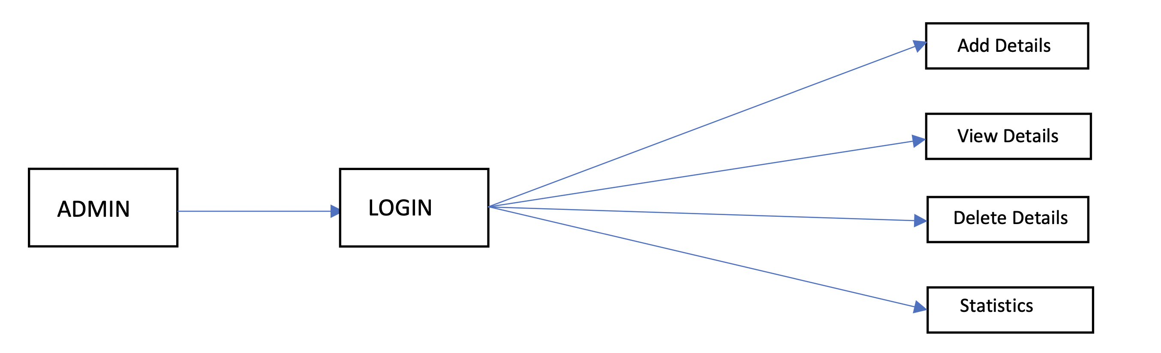

Fig (1.0)

ADMIN MODULE: In above Fig. 1.0,

Admin module is designed to add or delete records, view statistical records, maintaining student details, managing detail.

Admin will have the access to following sections-

* Add Details: Admin can add new member in the list of library data.
* View Details: Admin can view details and manage all the data at once place.
* Delete details: Admin can delete or manage the details in the library details.
* View User Details: In this section Admin can view the details of registered user.
* Add/Delete User: In this section admin can add new user and delete existing user.

# Model to be used for Project:

SDLC – WATERFALL MODEL:

The Waterfall Model was first Process Model to be introduced. It is also referred to as a linear sequential life cycle model. It is very simple to understand and use. In a waterfall model, each Phase must be completed before the next phase can begin and there is no overlapping in the phases. Waterfall model is the earliest SDLC approach that was used for software development.

The waterfall Model illustrates the software development process in a linear sequential flow; hence it is also referred to as a linear sequential life cycle model. This means that any phase in the development process begins only if the previous phase is complete. In waterfall model phases do not overlap.

Waterfall approach was first SDLC Model to be used widely in Software Engineering to ensure success of the project. In "The Waterfall" approach, the whole process of software development is divided into separate phases. In this Waterfall model, typically, the outcome of one phase acts as the input for the next phase sequentially. The advantages of waterfall development are that it allows for departmentalization and control. A schedule can be set with deadlines for each stage of development and a product can proceed through the development process model phases one by one. Development moves from concept, through design, implementation, testing, installation, troubleshooting, and ends up at operation and maintenance. Each phase of development proceeds in strict order.

## **Technology Use**

* Python

Python is a high-level Python is a high-level, interpreted, general-purpose programming language. Its design philosophy emphasizes code readability with the use of significant indentation. Python is dynamically-typed and garbage-collected. It supports multiple programming paradigms, including structured (particularly procedural), object- oriented and functional programming. It is often described as a "batteries included" language due to its comprehensive standard library. Guido van Rossum began working on Python in the late 1980s as a successor to the ABC programming language and first released it in 1991 as Python 0.9.0. And till now the latest one is Python 3.10.0.

* tkinter GUI

Python offers multiple options for developing GUI (Graphical User Interface). Out of all the GUI methods, tkinter is the most commonly used method. It is a standard Python interface to the Tk GUI toolkit shipped with Python. Python with tkinter is the fastest and easiest way to create the GUI applications. Creating a GUI using tkinter is an easy task.

* IDE - Eclipse / NetBeans

Eclipse and NetBeans are **the most commonly used Integrated Development Environment (IDEs) to design, build, test and deploy python applications and frameworks**, compared for their features. Eclipse. NetBeans. Open-source Java development platform for Java, C/C++, Perl, PHP, Ruby, Python, Java Script and Scala.

* SQLite

SQLite is a C library that provides a lightweight disk-based database that doesn’t require a separate server process and allows accessing the database using a nonstandard variant of the SQL query language. Some applications can use SQLite for internal data storage. It’s also possible to prototype an application using SQLite and then port the code to a larger database such as PostgreSQL or Oracle.

## **Implementation**

**Steps for Admin login:**

* Step 1: Start.
* Step 2: Click on Admin Login Button.
* Step 3: Enter login details of admin.
* Step 4: Click on Login Button.
* Step 5: Perform the required Admin module task.
* Step 6: Click on Log Out button to stop.

Make sure your System requirement is fulfilled as per the given in the documentation. Then login with the credentials given by the developers of the program. After successfully login into the program with correct credentials. Else you’ll not able to login into the program. Now since your are in the program now you have access to the data base and all the available books in the library. Even you can check the books given to the student or the teachers. Even you can manage the fine collected or not.

**Admin login**

## **Execution /System Outputs**

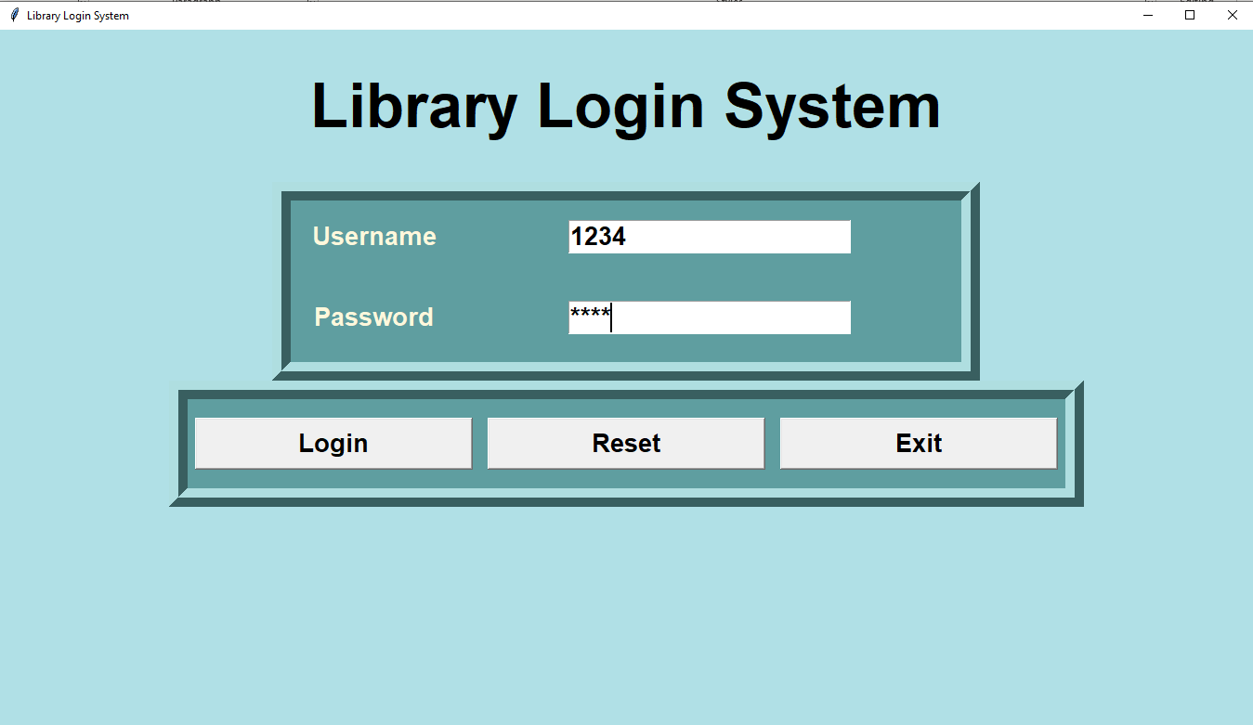

Fig. (1.1)

In above Fig. 1.1 You can see the basic login page, it is secured with the ID pass which is given to the librarian.

**Secured login**

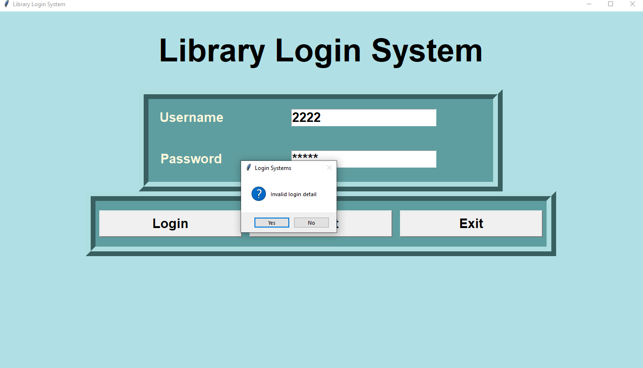

Fig (1.2)

In above fig. 1.2, you can see we have put wrong credentials to check that our program is secured or not. If the login ID Pass is incorrect then you can’t access the database.

**Admin module**

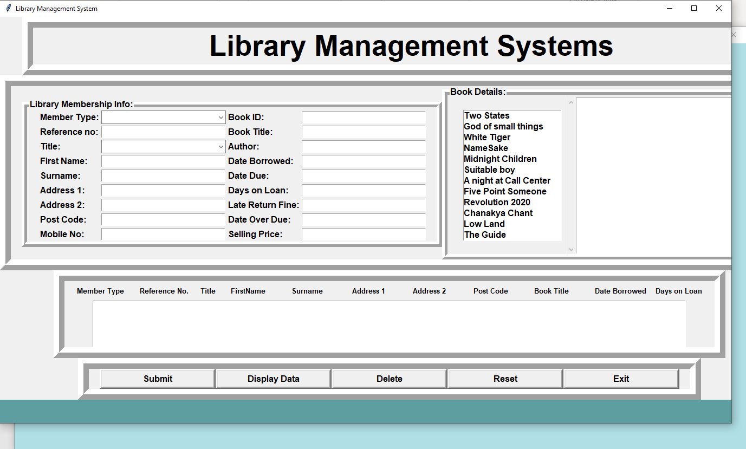

Fig (1.3)

In above Fig. 1.3, you can see the basic form or basic window of the program. Here you can register the new student and add books available in the library.

**Example how details are put in database**

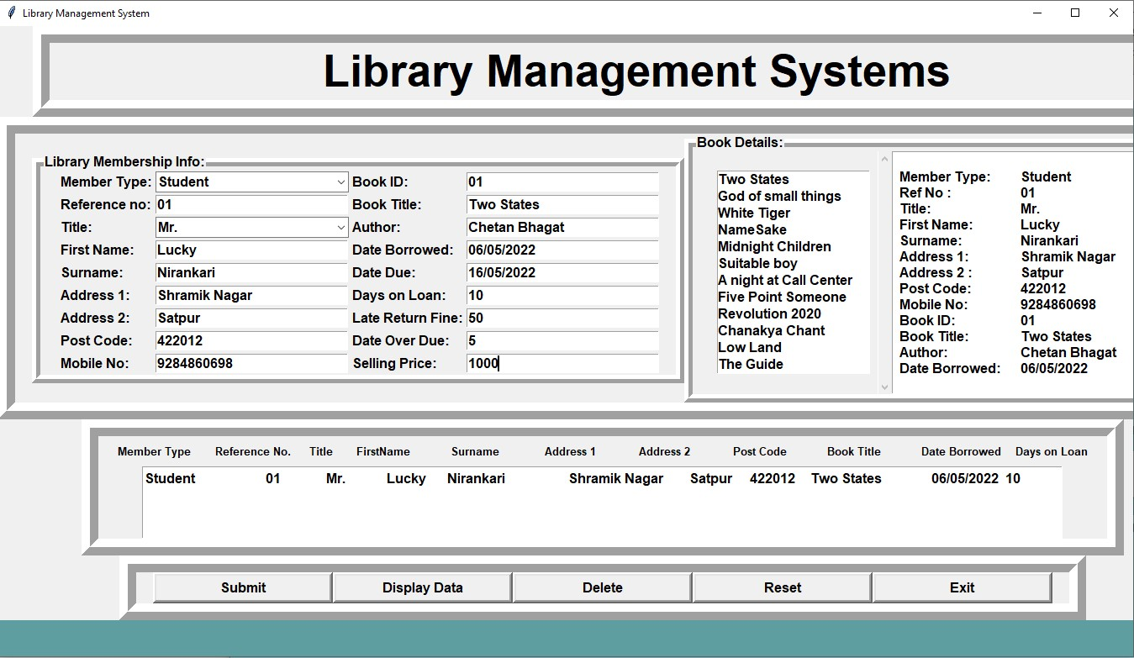

Fig (1.4)

In above Fig. 1.3, Here you can see the basic form or basic window of the program. Here we have put some example of library data for an example that you it will look. Here you can see the date when he /she has took the book from the library, when he/she has to return the book to the library

# Outcome

* + To make the existing system more efficient.
  + To provide a user-friendly environment where user can be serviced better
  + Make functioning of library faster
  + To minimize the loss done to books
  + The proposed library management system in this proposal will be a computerized managed system developed to maintain all the daily work of library.
  + The main focus of this project is to lessen the human effort and encourage efficient record keeping**.**

# CONCLUSION

In this paper, a Python based user interactive database management system is successfully developed, which is much applicable to University libraries. Using this software any user without having any knowledge of Python could easily be able to understand the graphical reports of various transactions like availability of books, number of copies, fine etc. Proper security has also been maintained, so that only authorized users permitted by the admin could access the services. This software can be run on any operating system having Python virtual machine. From a proper analysis of positive points and constraints, it can be concluded that this is highly efficient GUI based software. This library management system is working properly and meeting to all user requirements according to the educational institutions. After we have completed the project we are sure the problems in the existing system would overcome. The “LIBRARY MANAGEMENT SYSTEM” process made computerized to reduce human errors and to increase the efficiency. The main focus of this project is to lessen human efforts. The maintenance of the records is made efficient, as all the records are stored in the ACCESS database, through which data can be retrieved easily. The navigation control is provided in all the forms to navigate through the large amount of records. If the numbers of records are very large then user has to just type in the search string and user gets the results immediately. The editing is also made simpler. The user has to just type in the required field and press the update button to update the desired field. The Books and Students are given a particular unique id no. So that they can be accessed correctly and without errors. Our main aim of the project is to get the correct information about a particular student and books available in the library. The problems, which existed in the earlier system, have been removed to a large extent. And it is expected that this project will go a long way in satisfying users requirements. The computerization of the Library Management will not only improves the efficiency but will also reduce human stress thereby indirectly improving human recourses.

## **Future Works**

In near future, mobile-based applications rather than web based and desktop, will be developed. Besides, this software will be extended by adding more features after getting feedbacks from the customers Only covers the requirements specifications for the library management system. Does not provide any other information about library management system. Does not provide any references to the other component of the library management system. All the dependencies are also identified in this document. Updates the manually library system into a software-based application Any education institute & government offices can make use of it for providing information about author, content of the available books etc. This project can further be extended by adding the facility of e-book's, to overcome the problem of book stock in library. create distinct product users based on their roles and permissions. Authenticate users at their login. Provide the list of books the users can borrow. Facility to reserve books that are available. A status page for all users to view books reserved by them. Facility to cancel the reservation for a book made earlier. A status page for all users to view books borrowed by them, their individual due dates and their individual penalties if any. An interface to view and edit the own profile. Provide method for adjusting account settings such as passwords. Mechanism to reset the password in case user forgets it. Providing interface to add or delete books to staffs.

## References

* Python Tkinter documentation
* SQlite Documentation
* <https://docs.python.org/3/>
* <https://docs.python.org/3/library/tk.html>